___________ __________ _____________________
Roll No Section Student Signature
Digital Logic Design (EE1005)
Date: April 9th 2026
Course Instructors:
Dr. Rabia Tabassum, Sir Javed Quershi, Dr. M Adeel, Ms. Hira Tunio, Ms. Sana Naz, Mr. Ishtiaq Ahmed, Mr. M Miqdad Khan, Mr. M Rahim, Mr. Abuzar Zafar, and
Dr. Muhammad Nouman Durrani
Sessional-II Exam
Total Time (Hrs): | 1
Total Marks: | 30
Total Questions: | 2

Do not write below this line
Attempt all the questions in the given sequence.

CLO # 2: Demonstrate the acquired knowledge to apply techniques related to the design and analysis of digital electronics circuits, including Boolean Algebra and Multi-variable Karnaugh map methods.

Design and analysis of digital electronics circuits. [ 6 + 2 = 8 Marks]
Time: 20 Minutes

Q1: (a) Consider a 3-bit unsigned binary number X=X₂​X₁​X_{0​.} A logical circuit produces an output Z=Z₂​Z₁​Z₀​
such that:
Z = X−1
For example:
- If X=000, then Z=111 ► Z = 000 + (2’s complement of 1) ► Z= 000+111
- If X=101, then Z=100 ► Z = 101 + (2’s complement of 1) ► Z= 101+111
- Construct the complete truth table for the above 3-bit logical circuit.
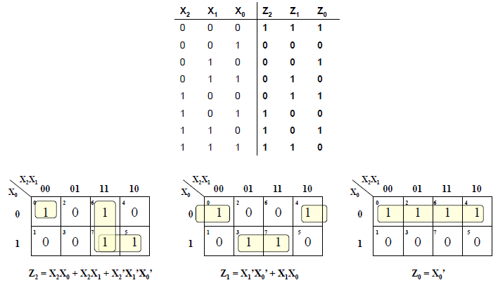
- Derive the simplified Boolean expressions for each output bit Z₂​,Z₁​,Z₀​ using K-map minimization.

- Draw the logical circuit of the above Boolean expression for Z₂ only using NAND gate.
(b) Implement the NOT gate using a 2:1 Multiplexer.

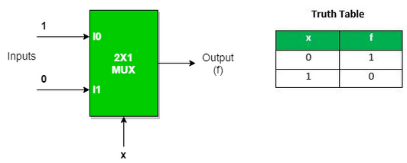

CLO # 3 Analyze small –scale combinational digital circuits.

Design and analysis of Combinational Logic Circuits: [4 + 4 + 4 + 2 + 2 + 6 = 22 Marks]
Time: 40 Minutes

Q2: (a) Using only four-bit adders, construct an eight-bit adder. Each four-bit adder has two four-bit inputs and one five-bit output. Your eight-bit adder should have two eight-bit inputs and a one eight-bit output.

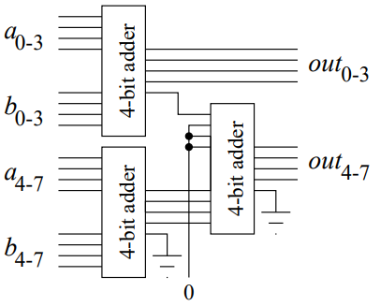
(b) Using two 2-to-4 decoders with enable (EN) inputs, construct a 3-to-8 decoder. Provide a labeled logic diagram
and explain how the enable signals are utilized.
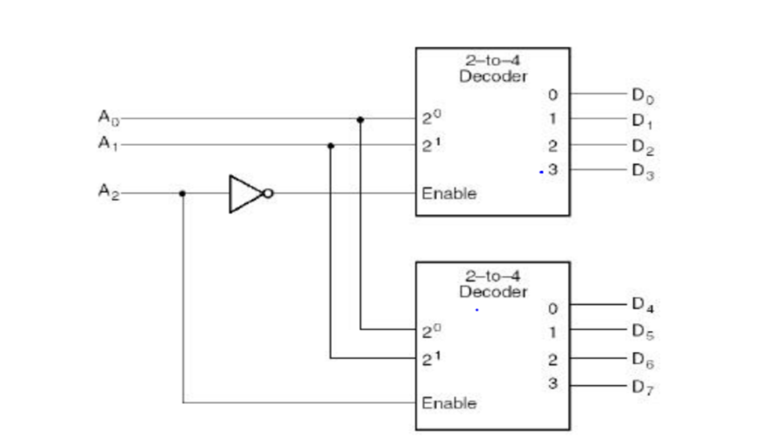

(c) Implement the given Boolean function using an 8-to-1 multiplexer (8×1 MUX). Assume A₀ as the least
significant bit (LSB).
F( A₃, A₂ , A₁ , A₀ ) = $\sum{m}$ (0, 3, 4, 5, 7, 11, 13,14)
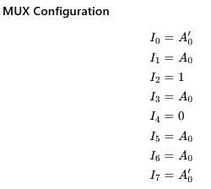

(d) A 7-segment decoder/driver drives the display in the given Figure 1. If the waveforms are applied as indicated,
determine the sequence of digits that appears on the display. [Solve here on the question paper].
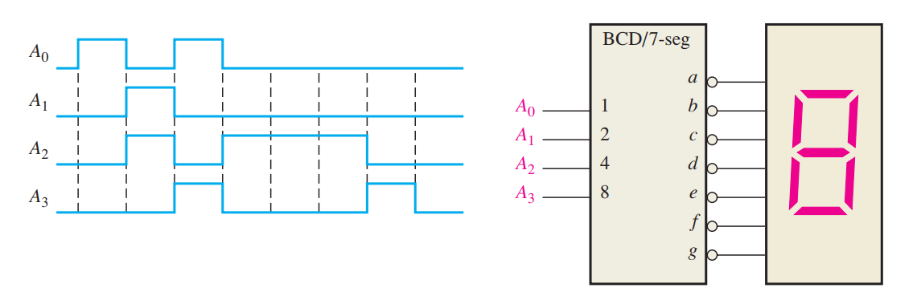
Figure 1
Start 0, 1, 6, 9, 4, 4, 4, 8, 0

(e) The serial data-input waveform (Data in) and data-select inputs (S0 and S1) are shown in Figure 2. Determine the data-output waveforms on D0 through D3 for the demultiplexer in Figure 2. [Solve here on the question paper].
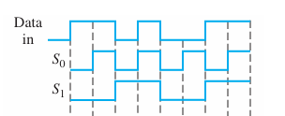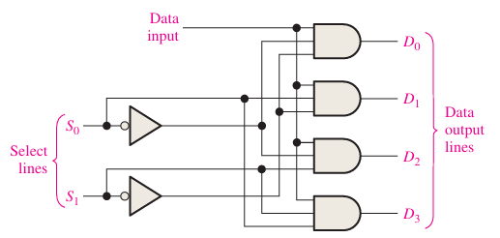
Do 1 0 0 0 0 0 0 0
Figure 2
D1 0 1 0 0 0 0 0 0
D2 0 0 1 0 0 0 1 0
D3 0 0 1 1 0 0 0 1

(f) A 4-to-2 encoder is a combinational circuit that converts one active input out of four into a 2-bit binary code.
Now consider a 4-to-2 encoder with inputs D₃,D₂,D₁,D₀ ​ and outputs Y₁​,Y₀​. Assume that only one input is HIGH at a time.
(i) Construct the truth table of the encoder.
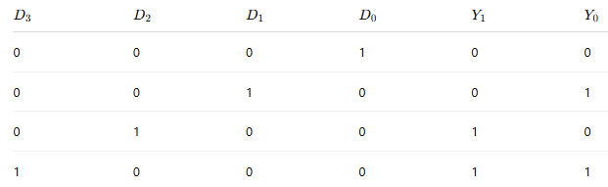
(ii) Derive the Boolean expressions for outputs Y₁​ and Y₀​.
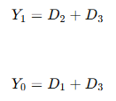
- What will happen if more than one input is HIGH simultaneously? Briefly explain.
If more than one input is HIGH at the same time:
- The output becomes ambiguous (incorrect)
- Example:
  - If D2​=1 and D3​=1
  - Output becomes:
Y1​=1,Y0​=1
  - This corresponds to D3​, but D2​ is also active → information loss
A simple encoder cannot handle multiple active inputs.
This limitation is resolved using a priority encoder.

